**Chapter 1-Introduction to Project**

There are many tools related to disease analysis. But particularly heart related diseases, tuberculosis, malaria have been analysed and risk level is generated. But generally there are no such tools that are used for prediction of general diseases. So Disease Predictor helps for the prediction of the general diseases analysis and diagnosing of disease become a challenging factor faced by doctors and hospitals both in India and abroad. In order to reduce the large scale of deaths from disease, a quick and efficient Prediction technique is to be discovered. The researchers accelerating their research works to develop a software with the help machine learning algorithm which can help doctors to take decision regarding both prediction and diagnosing of disease. The main objective of this project is predicting the disease of a patient using machine learning algorithms. Comparative study of the various performance of machine learning algorithms is done through graphical representation of the results. The highest mortality of both India and abroad is due to disease. So it is vital time to check this death toll by correctly identifying the disease before time. The matter become a headache for all doctors both in India and abroad. Now a days doctors are adopting many scientific technologies and methodology for both identification and diagnosing not only common disease, but also many fatal diseases. The successful treatment is always attributed by right and accurate diagnosis. Doctors may sometimes fail to take accurate decisions while diagnosing the disease of a patient, therefore disease prediction systems which use machine learning algorithms assist in such cases to get accurate results.

## Technologies used:

* + - Python
    - Machine learning
    - Tkinter

## Objectives of project

The objectives of the project DISEASE ANALYSIS are:

1. To find the rate of disease in human beings.
2. To measure the probability of a user for having disease.
3. To implement rule based algorithm as analysing technique into a system.
4. To predict that whether a person will have disease or not.
5. To represent and measure the variation of each factor responsible for disease.

# Chapter 2- System requirements

### Table No: 2.1 Hardware Specification

|  |  |
| --- | --- |
| Operating System | Windows 7 and above |
| Processor | Intel Core Series or AMD Ryzen Series |
| Speed | 3.0 GHZ |
| Memory | 4 GB RAM |
| Hard Disk Drive | 250MB |

**Table No: 2.2 Software Specification**

|  |  |
| --- | --- |
| Development Environment | PyCharm IDE |
| Language | Python |
| Front End | Python(tkinter) |
| Back End | Python |

**Chapter 3- Feasibility Study**

#### Legal Feasibility

Legal feasibility is an analysis performed to understand if the proposed plan conforms the legal and ethical requirements. These requirements may involve zoning laws, data protection acts, or social media laws, etc.

For example, your company is planning to open a branch in a new region. According to the studies you recognize that the country does not allow an individual foreigner owning a property. Therefore, you select the rental option instead of buying.

#### Economic Feasibility

An economic feasibility study involves a [cost benefits analysis](https://www.projectcubicle.com/cost-benefit-analysis-example/) to identify how well, or how poorly, a project will be concluded. You calculate the [expected monetary value](https://www.projectcubicle.com/expected-monetary-value-emv-calculation/) of each cost and benefit separately do decide if the project is economically feasible or not.

For example, your company is planning to perform a housing project on the west coast of the city. In order to understand if the project is economically feasible, you will calculate the duration, cost and the income of the project. If the calculations demonstrate a short payback period, the board of directors will decide to undertake the project.

#### Technical Feasibility

Technical feasibility is a broad concept which can be applied to a software development project, pipeline construction project or a military project. Each project requires different technical specifications and standards. Technical feasibility is the process of validating the technical resources and capabilities to convert the ideas into working systems.

For example, your company is planning to improve the current network infrastructure. You analyzed the new system and concluded that the new system can use the organization’s existing network infrastructure. This shows that a new system is technically feasible.

#### Operational Feasibility

Operational feasibility is performed to understand well a proposed system solves the problems. From this aspect, operational feasibility studies are critical for system engineering and affect early design phases.

For example, your company has undertaken a project to build a new theme park for a client. Then you performed a study to determine how the theme park will operate in a way that is conducive to its inhabitants, parking, dining, human flow, accessibility. This can be an example of operational feasibility.

#### Scheduling Feasibility (Time Feasibility)

Completing a project on time is very important from an investors perspective. Scheduling feasibility is a measure of how reasonable the project duration is. If the project takes longer than estimated, investors will have to bear extra costs.

For example, an investor proposed a hotel construction project to your company. However, he requested that the project will be completed in one year. The project team conducted a feasibility study based on a list of requirements to complete the project on time.

#### Economic & Ecological Analysis

Economics is the study of value, costs, resources, and their relationship in a given context or situation. In the discipline of software engineering, activities have costs, but the resulting software itself has economic attributes as well. Software engineering economics provides a way to study the attributes of software and software processes in a systematic way that relates them to economic measures.

# Chapter 4 -Methodology/ Planning of work

### Methodology:

**Step 1**: Data collection and dataset preparation This will involve collection of medical information from various sources like hospitals, then pre-processing is applied on dataset which will remove all the unnecessary data and extract important features from data.

**Step 2**: Developing a probabilistic model and deep learning approach (RNN) for Disease Prediction in this step probabilistic model and deep learning approach based on RNN is to be developed it will run effectively on extensive databases of healthcare. And generate decision tree also it can deal with a huge number of information variables without variable deletion.

**Step 3**: Training and experimentation on datasets The Disease Prediction model will be trained on the dataset of diseases to do the prediction accurately and produce Confusion matrix. In this project 3 different algorithms were used -

* Decision Tree
* Random Forest
* Naïve Bayes

**Step 4**: Deployment and analysis on real life scenario The trained and tested prediction model will be deployed in a real-life scenario made by the human experts & will be leveraged for further improvement in the methodology.

#### Iterative Waterfall Method

What is the most common way to plan out a project? Sequence the tasks that lead to a final deliverable and work on them in order. This is the Waterfall methodology — the traditional method for managing projects and the one that is simplest to understand. One task must be completed before the next one begins, in a connected sequence of items that add up to the overall deliverable. It’s an ideal method for projects that result in physical objects (buildings, computers), and project plans can be easily replicated for future use.

The power of this methodology is that every step is preplanned and laid out in the proper sequence. While this may be the simplest method to implement initially, any changes in customers’ needs or priorities will disrupt the sequence of tasks, making it very difficult to manage.

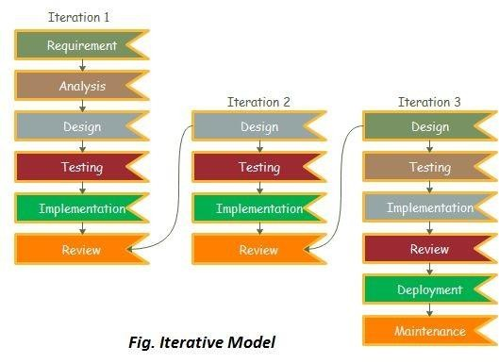

# Chapter 5- Data Flow Diagram

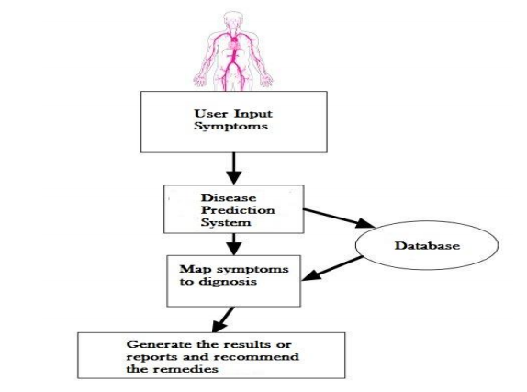

**Chapter 6- Screenshots**

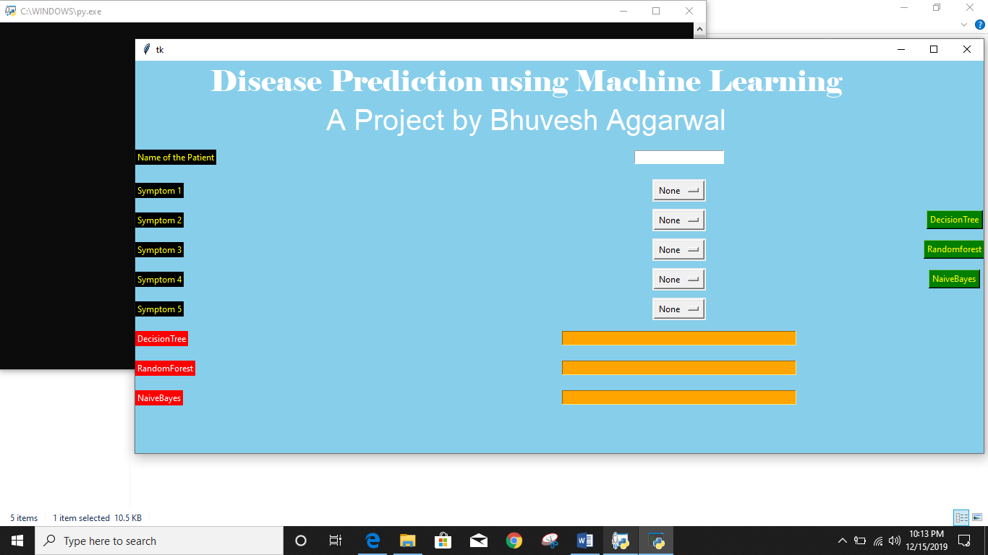

Fig 6.1: Graphical User Interface of System

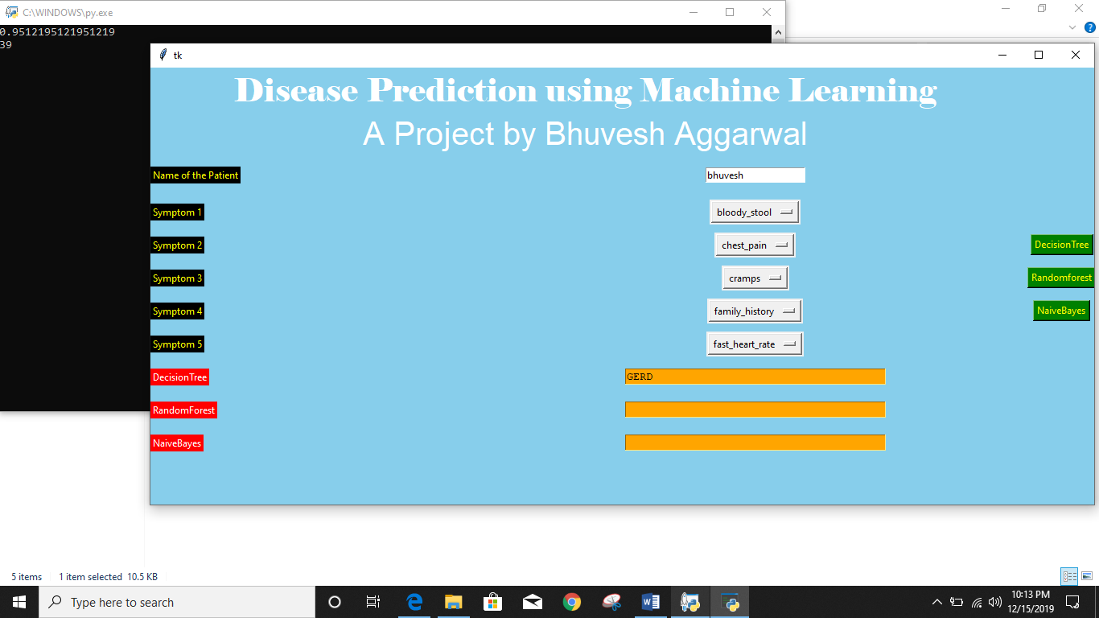

Fig 6.2: Graphical User Interface of System

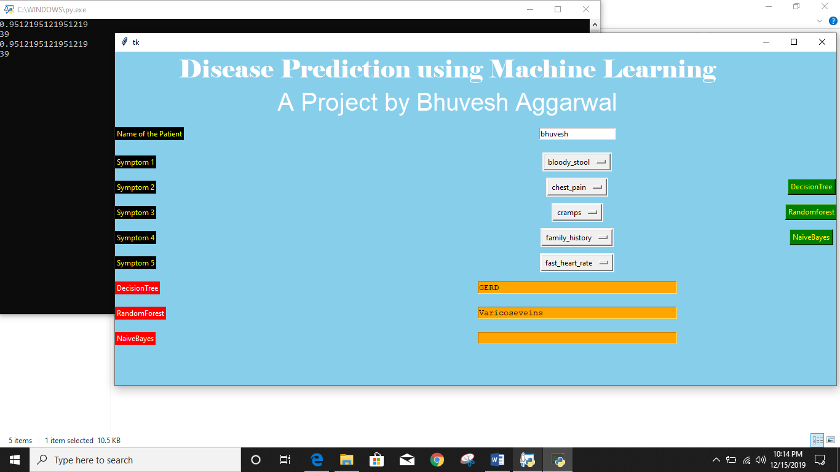

Fig 6.3: Graphical User Interface of System

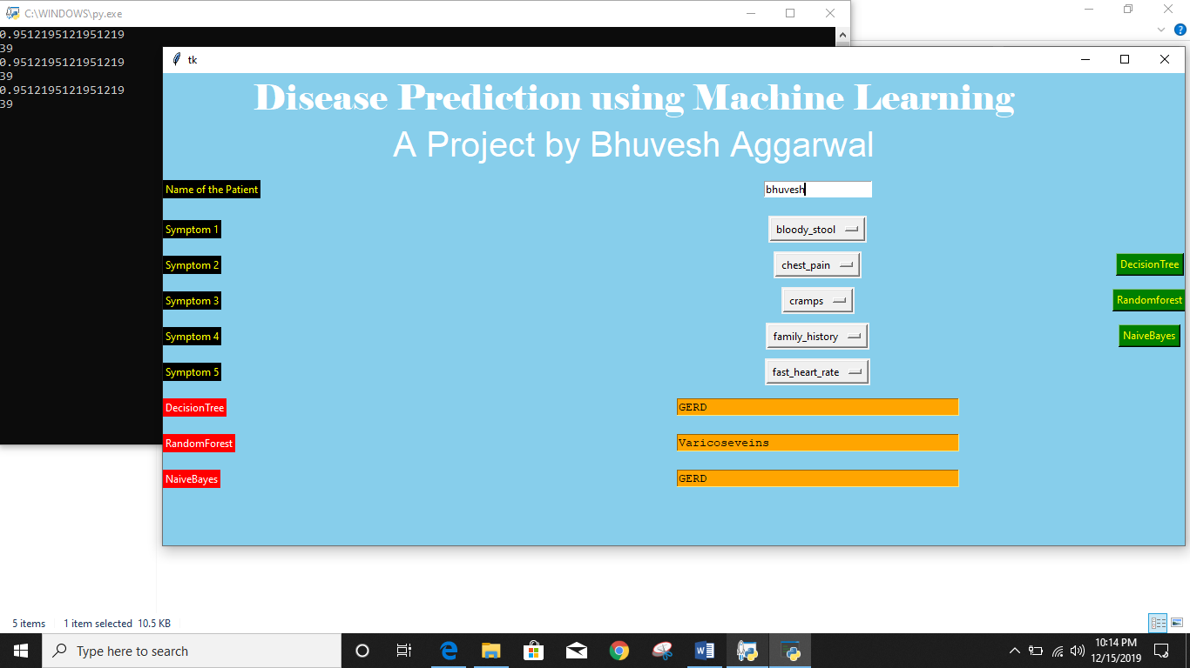

Fig 6.4: Graphical User Interface of System

**Chapter 7 –References**

[1] Kaveeshwar, S.A., and Cornwall, J., 2014, “The current state of disease mellitus in India”. AMJ, 7(1), pp. 45-48.

[2] Dean, L., McEntyre, J., 2004, “The Genetic Landscape of Disease [Internet]. Bethesda (MD): National Center for Biotechnology Information (US); Chapter 1, Introduction to Disease. 2004 Jul 7.

[3] Mohammed, A.K., Sateesh, K. P., Dash G. N., 2013, “A Survey of Data Mining Techniques on Medical Data for Finding Locally Frequent Diseases” International Journal of Advanced Research in Computer Science and Software Engineering, 3(8), pp. 149-153.

[4] Chunhui, Z., Chengxia, Y., 2015, “Rapid Model Identification for Online Subcutaneous Glucose Concentration Prediction for New Subjects with Type I Disease”, IEEE Transactions on Biomedical Engineering, 62 (5), pp. 1333 – 1344

[5] Vaishali, A., Harsh, K., Anil, K.A, 2016, “Performance Analysis of the Competitive Learning Algorithms on Gaussian Data in Automatic Cluster Selection”, 2016 Second International Conference on Computational Intelligence & Communication Technology.